How to install U9 Auto-Install Wireless Adapter
Model Number: U9 Auto-Install Wireless Adapter
Question Classification: Configuration

Step 1: Plug adapter into PC

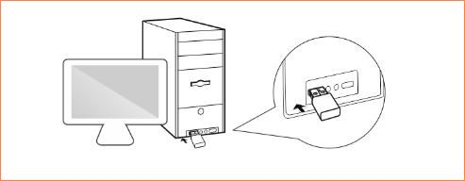

Step 2: Pop up window and tap “Run Setup.exe”.

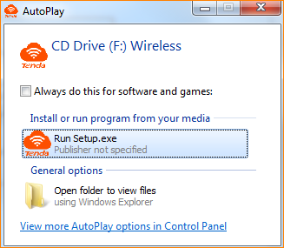
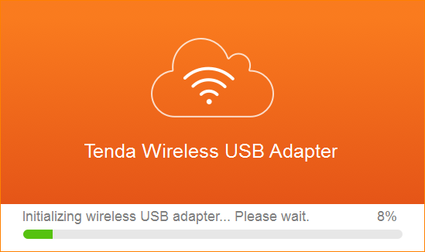

Note: Configuration is successful after shown on the lower right corner of the desktop.

